**ASSIGNMENT – 10**

**ON: USING SET OPERATORS**

**Q1. List the department IDs for departments that do not contain the job ID ST_CLERK, using set operators.**

|  |
| --- |
| **DEPARTMENT_ID** |
| **10** |
| **20** |
| **60** |
| **80** |
| **90** |
| **110** |
| **190** |

**7 rows selected.**

Ans1.

SELECT DEPARTMENT_ID

FROM DEPARTMENTS

MINUS

SELECT DEPARTMENT_ID

FROM EMPLOYEES

WHERE JOB_ID = 'ST_CLERK';

**Verification table -**

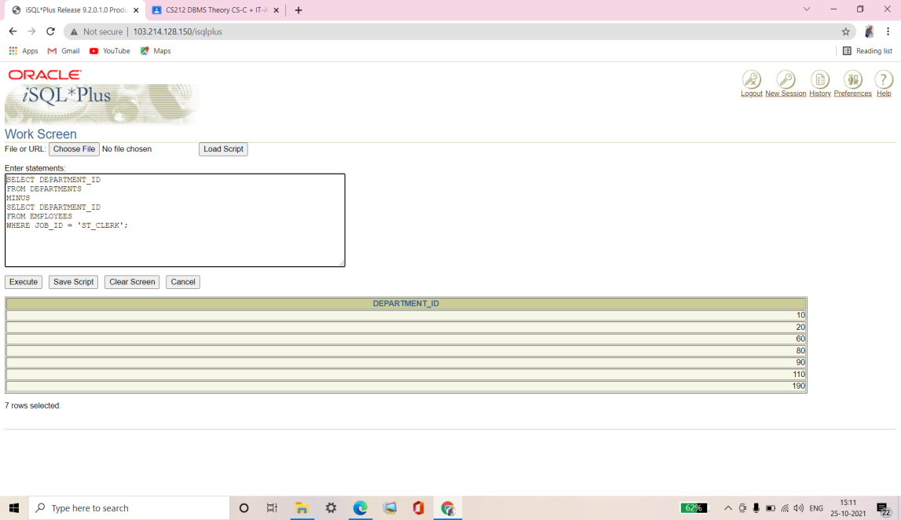

**Q2. Display the country ID and the name of the countries that have no departments located in them, using set operators.**

|  |  |
| --- | --- |
| **CO** | **COUNTRY_NAME** |
| **DE** | **Germany** |

Ans2.

SELECT COUNTRY_ID, COUNTRY_NAME

FROM COUNTRIES

MINUS

SELECT l.COUNTRY_ID, c.COUNTRY_NAME

FROM LOCATIONS l, COUNTRIES c

WHERE l.COUNTRY_ID = c.COUNTRY_ID;

**Verification table -**

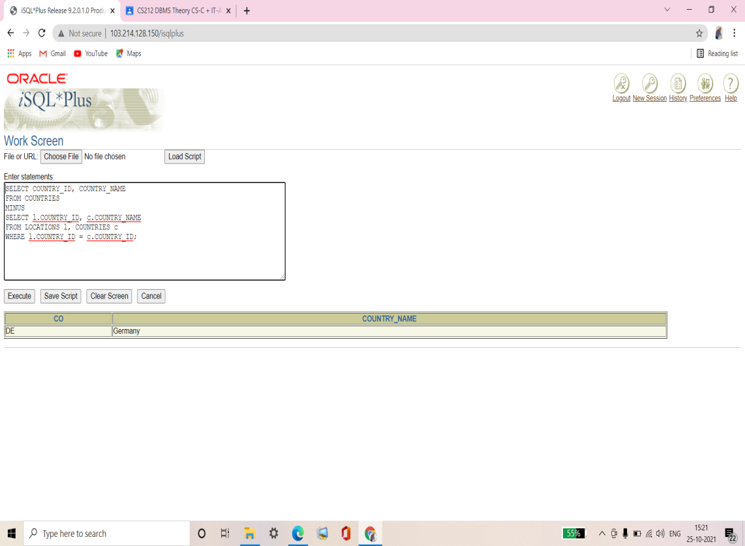

**Q3. Produce a list of jobs for departments 10, 50, and 20, in that order. Display job ID and department ID, using set operators.**

|  |  |
| --- | --- |
| **JOB_ID** | **DEPARTMENT_ID** |
| **AD_ASST** | **10** |
| **ST_CLERK** | **50** |
| **ST_MAN** | **50** |
| **MK_MAN** | **20** |
| **MK_REP** | **20** |

Ans3.

COLUMN dummy NOPRINT

SELECT JOB_ID, DEPARTMENT_ID, 1 dummy

FROM EMPLOYEES

WHERE DEPARTMENT_ID = 10

UNION

SELECT JOB_ID, DEPARTMENT_ID, 2

FROM EMPLOYEES

WHERE DEPARTMENT_ID = 50

UNION

SELECT JOB_ID, DEPARTMENT_ID, 3

FROM EMPLOYEES

WHERE DEPARTMENT_ID = 20

ORDER BY 3;

**Verification table -**

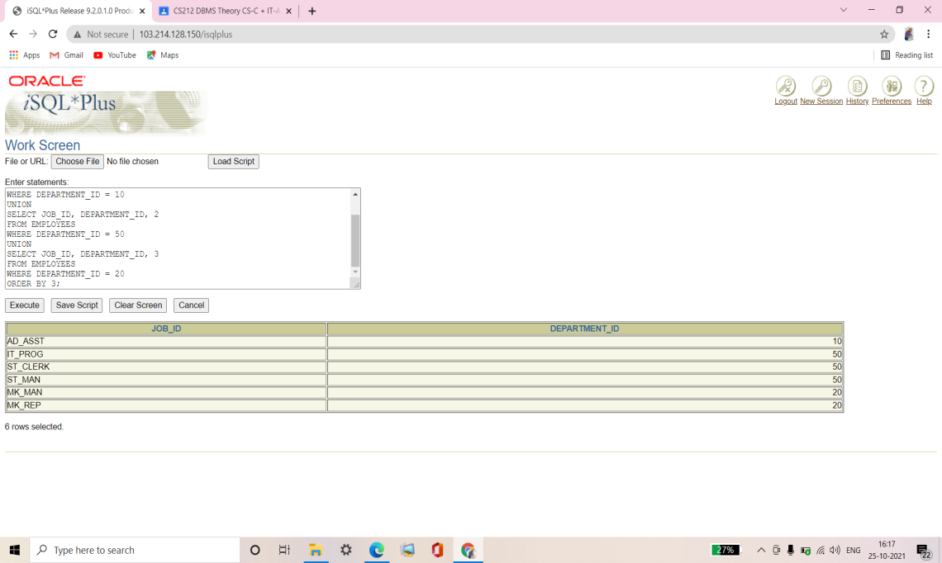

**Q4. List the employee IDs and job IDs of those employees who are currently in the job title that they have held once before during their tenure with the company.**

|  |  |
| --- | --- |
| **EMPLOYEE_ID** | **JOB_ID** |
| **176** | **SA_REP** |
| **200** | **AD_ASST** |

Ans4.

SELECT EMPLOYEE_ID, JOB_ID

FROM EMPLOYEES

INTERSECT

SELECT EMPLOYEE_ID, JOB_ID

FROM JOB_HISTORY;

**Verification table -**

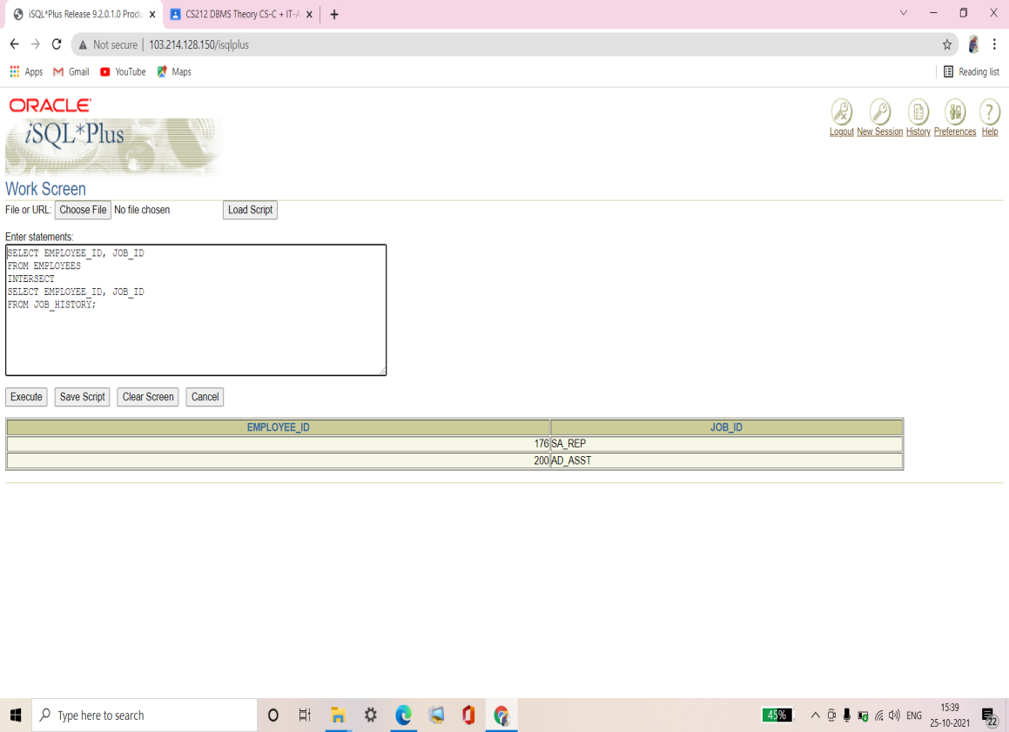

**Q5. Write a compound query that lists the following:**

* **List names and department ID of all the employees from the EMPLOYEES table, irrespective of the fact whether they belong to any department or not.**
* **Department ID and department name of all the departments from the DEPARTMENTS table, irrespective of the fact whether they have employees working in them or not.**

|  |  |  |
| --- | --- | --- |
| **LAST_NAME** | **DEPARTMENT_ID** | **TO_CHAR(NULL)** |
| **Abel** | **80** |  |
| **Davies** | **50** |  |
| **De Haan** | **90** |  |
| **Ernst** | **60** |  |
| **Fay** | **20** |  |
| **Gietz** | **110** |  |
| **Grant** |  |  |
| **Hartstein** | **20** |  |
| **Higgins** | **110** |  |
| **Hunold** | **60** |  |
| **King** | **90** |  |
| **Kochhar** | **90** |  |
| **Lorentz** | **50** |  |
| **Matos** | **50** |  |
| **Mourgos** | **50** |  |
| **Rajs** | **50** |  |
| **Taylor** | **80** |  |
| **Vargas** | **50** |  |
| **Whalen** | **10** |  |
| **Zlotkey** | **80** |  |
|  | **10** | **Administration** |
|  | **20** | **Marketing** |
|  | **50** | **Shipping** |
|  | **60** | **IT** |
|  | **80** | **Sales** |
|  | **90** | **Executive** |
|  | **110** | **Accounting** |
|  | **190** | **Contracting** |

**28 rows selected.**

Ans5.

SELECT LAST_NAME, DEPARTMENT_ID, TO_CHAR(NULL)

FROM EMPLOYEES

UNION

SELECT TO_CHAR(NULL), DEPARTMENT_ID, DEPARTMENT_NAME

FROM DEPARTMENTS;

**Verification table -**

